# This file is purely a demonstration of how I structured my Advice and Extra Content files. You won’t learn much from this and don’t bother trying. Everyone makes different mistakes when practising past papers. You should practise past papers yourself and try to come up with a similar file yourself. It’s the process of making the file that’s important, not the file itself.

# General Advice

* Label the points of intersection and the asymptotes for any sketch.
* Careful when a model is used as you may have to scale it.
* Remember the GCSE basics of the sine and cosine rule.
* Add units to your final answers, eg, metres for vector questions.
* “Fully justify your answer” would mean go ahead and whip out the definition like for bipartite.
* Expand and consider how limits would cancel. Eg, as x tends to infinity of x2/(2x+4)2
* Try and show things are the case with maths rather than words. Eg, matrix addition.

# Pure

## CA - Proof

* Explicitly state, “thus, by mathematical induction, the statement is true for all natural numbers.”
* For divisibility/multiplicity tests, you can either consider f(k + 1) - f(k) = d and thus f(k + 1) = f(k) + d where d should be a multiple **or** show it is true for n = k + 1 by pulling out a factor of n = k. This is because f(k + 1) - f(k) may not always work since it may be f(k + 1) - a x f(k) where a is some multiple.
  + Eg, showing f(n) = 8n - 5n is divisible by 3 for all natural numbers n.

## CB - Complex numbers

* In essence, z is just some complex number under some constraint.
* Be sure to state **“by De Moivre’s Theorem”** when using his theorem.
* Write for what values a half-line is valid. Eg, for x > 5.
* You may have to use methods learnt here in other areas. Eg, integrating sin4θ.
* Find the maximum value of |z| or ranges by logic and symmetry. Remember congruent triangles.

## CC - Matrices

* Remember that you can factorise matrix expressions like AB = I + 2A.
* If something is a combination of an enlargement (same sf on both axes) and rotation then the magnitude of the determinant can be used to find the sf of enlargement.
* Row and column operations can be useful with systems of equations and won’t affect the final result. You don’t need to write it outside the matrix. Just use row operations to reduce it to something nicer.

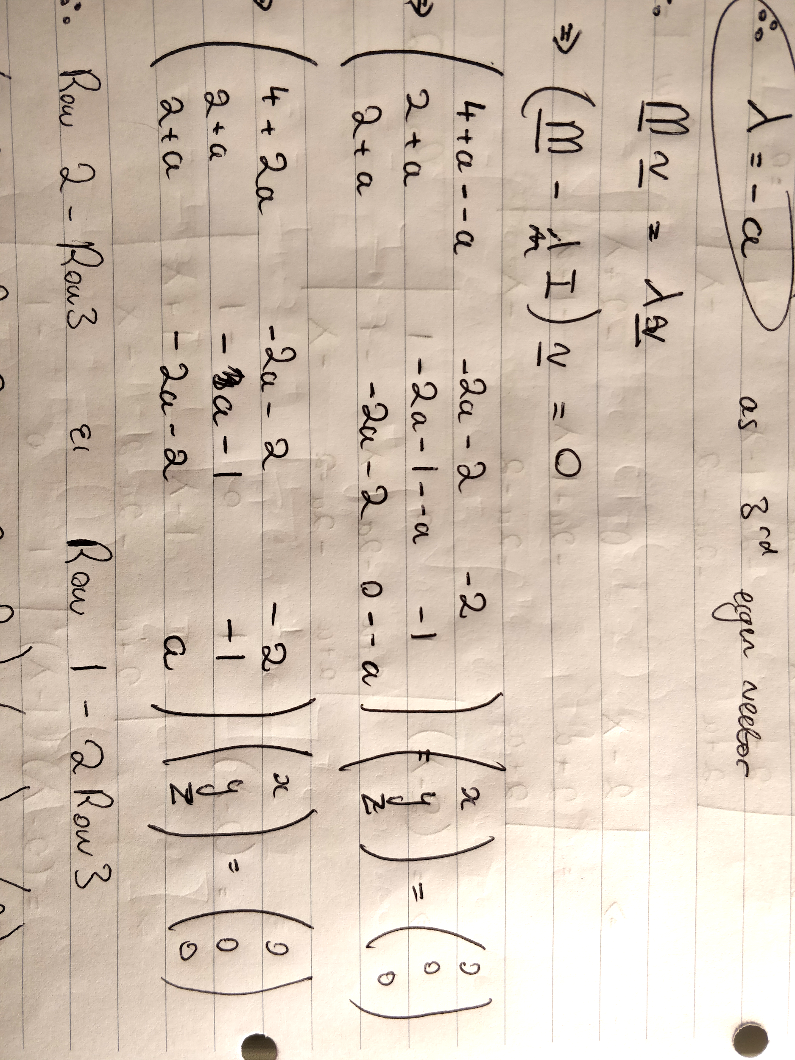

* Remember to pull down the power for diagonal matrices.
* Check to ensure that arcsin and arccos match up when finding the angle of rotation.
* Under matrix multiplication, remember you can only pre/post multiply. Eg, multiply both sides by E would give EAB = ECD or ABE = CDE.
* You use x and mx + c on the left, and x’ and mx’ + c on the right for invariant lines.
  + This is because you want the same line (same gradient and y-intercept).
  + If both m’s/c’s cancel then it can take on any m value or c value respectively.
* You can find eigenvectors a lot faster using the following:

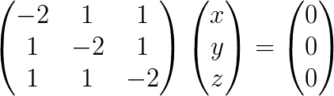

You can let x = 1 to get…

-2 + y + z = 0

1 - 2y + z = 0

Which gives the vector (1 1 1), it doesn’t matter if it’s a scalar multiple.

* If some values cancel in eigenvalues, the other can equal anything. Sorta like with systems of equations.
* Multiply an eigenvector by a number to cut out those nasty fractions.
* No unique solutions means an infinite number of solutions or no solutions.
* You can find all possible values when there is no solution by considering when there is a solution when its consistent.

## CD - Further algebra and functions

### Roots of Polynomials

* Turns out that the following does creep up (like in the 2018 paper):

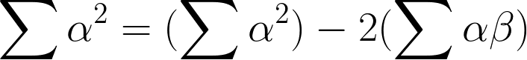

### Maclaurin series

* Check whether or not you can use the binomial series rather than jumping in with the chain rule and Maclaurin Series
* Use long division when dividing 2 series.
* Using series will give you the same result at L'Hopitals rule but bare in mind you have to use series on both the top and bottom of the fractions and you may be able to cancel X's on both the top and bottom.
* You may have you use the general formula for Maclaurin series rather than making endless substitutions.

### Rational functions

* Any value on the denominator (including x = 0) counts as a critical value so must be added to the number line.
* You need to multiply both sides of the inequality by the denominator if it less/greater than zero.
* You can consider whether something approaches an asymptote from above or below by considering both the numerator and denominator. Eg,

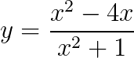

As x → ∞ then x2 - 4x < x2so it will approach from below. As → -∞ then x2 - 4x > x2so will approach from above.

### Parabolas, Ellipses, Hyperbola

* Make substitutions to make transformations much easier.
  + E.g., a stretch of 5 in the y-direction is technically doing y/5 = x yet you then multiply both sides by 5.
* You can leave answers (e.g., asymptotes of the hyperbola) in a simple form involving brackets.

## CE - Further calculus

* When asked to find the time period, the imaginary part of the complex root equals ω as light damping’s complementary function can be Acos(qt + B) (where q is the imaginary part of the complex root).
* If you work in the most general form, you will always get to the same result.
* Remember that you are considering x values as limits under surface areas of revolution and the other integrals.
* When you use L’Hopital’s rule, explain why you’re using it.
* If you’re showing a reduction formula and it only has In - 2 (with limits), you may have to use an identity.
* Common reduction formulae (without limits) are shown below:



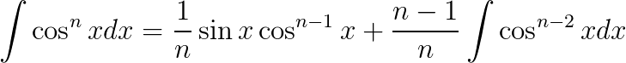

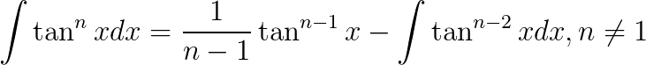

* For mean acceleration or mean velocity, remember that you will be dividing by time at the end anyway.
* Write 1 / (b - a) from the start for mean values, it makes the algebra a lot easier.
* It can be helpful to spot cases like x2 + y2 = r2 when evaluating some integrals. Like for the surface area of a sphere
* Remember limits tending towards zero from positive or negative for improper integrals.

## CF - Further vectors

* Draw a diagram for any question. It makes life so much easier.
* You can use any scalar multiple of the normal to a plane, it doesn’t matter.
* For the Cartesian equation of a line, write...



* Remember that α + θ = 90 for the normal line to a plane. So sinα = ½ then cosθ = cos(90 - α) = sin(α) = ½ too.

## CG - Polar coordinates

* For r = 8cos2θ, you have to type in r = 8(cosθ)2 into your graphing calculator.
* For polar coordinates, you can convert something weird into a cartesian equation to help you draw the same thing. It is the same curve, just the axis is different.
* Negative r values are reflected in the opposite direction:

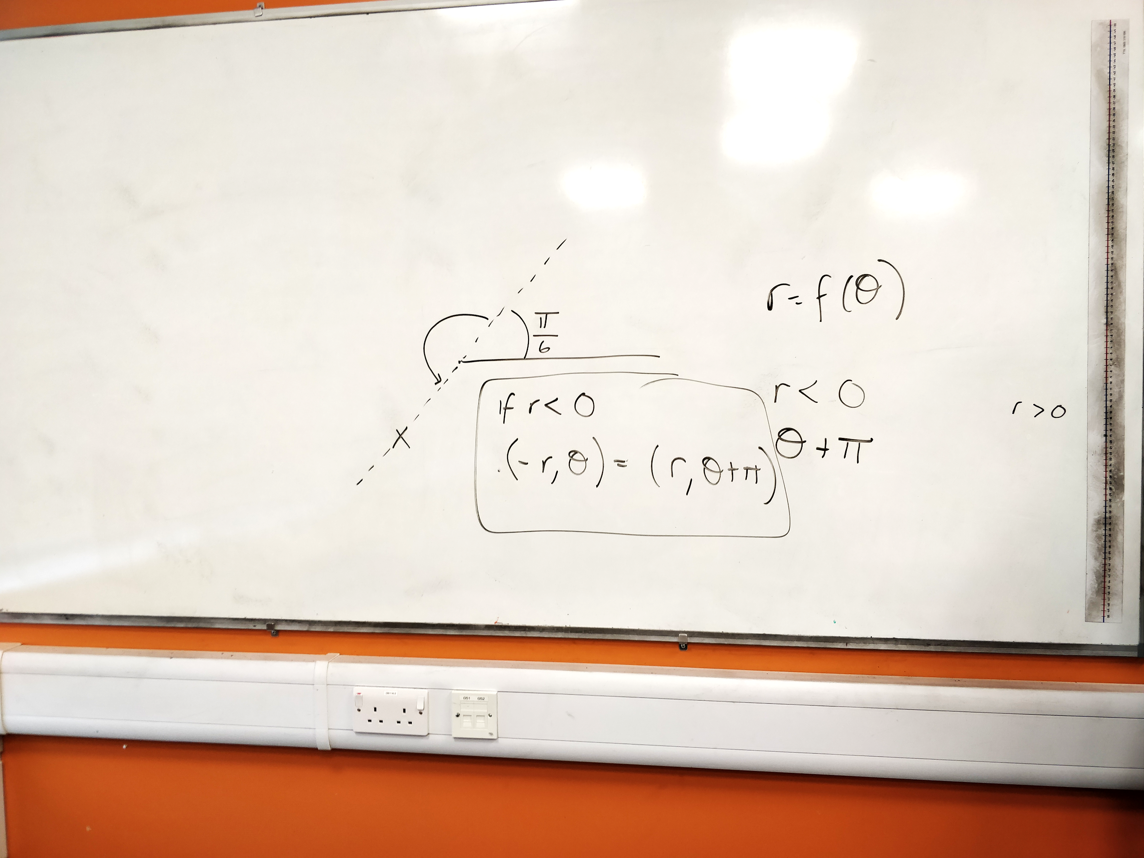

* Be sure to use the formula for integration with polar.
* Find when polar curve hits 0 to find where to integrate between.

## CH - Hyperbolic functions

* When differentiating inverse hyperbolics, consider the shape (always increasing).
* Be more specific, cosh x >= 1, not just cosh x > 0.
* Take care with reflections of hyperbolics, eg, x = cosh(y + b)

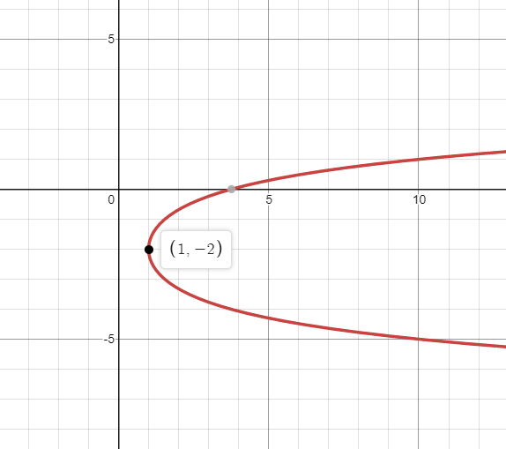

In the case where b = 2.

* You can prove cosh(ix) = cos(x) using Euler’s Identity quite easily.

## CI - Differential equations

* Consider directions when doing SHM questions - choose whichever direction is easier.
* Think logically at maximum compression, it will have zero speed.
* State the particular solution, don't just state c.

## CJ - Numerical methods

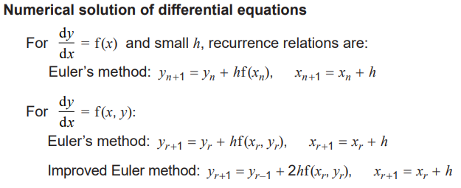

You may well have to rearrange into something as shown above.

* Ensure your layout is solid for this topic.

# Discrete

## DA - Graphs

* Pay careful attention to the keywords and their definitions (eg, a simple graph doesn’t necessarily have to be connected).
* For a graph to have the same number of edges of edges in a Hamiltonian cycle as the number of edges in an Eulerian trail, it must have 3 edges.
  + This is because the number of edges in a Hamiltonian cycle is the number of vertices and the number of edges in an Eulerian trialis n(n-1)/2. Both these sequences have 3 in them.

### Planar and non-Planar Graphs by Euler’s Formula

* You can use 2E ≥ 3F alongside Euler’s formula to show a graph is nonplanar.
* This comes from the fact that all faces are made up of 3 edges and when counting all the faces, each edge is counted at most twice (as an edge sits in at most 2 faces.)
* Don’t sweat it if you’re off by 1 or 2 for the shortest route in Chinese Postman, they usually accept at least 4 of the 6 correct. As long as you get the same answer.
* An example is shown below:

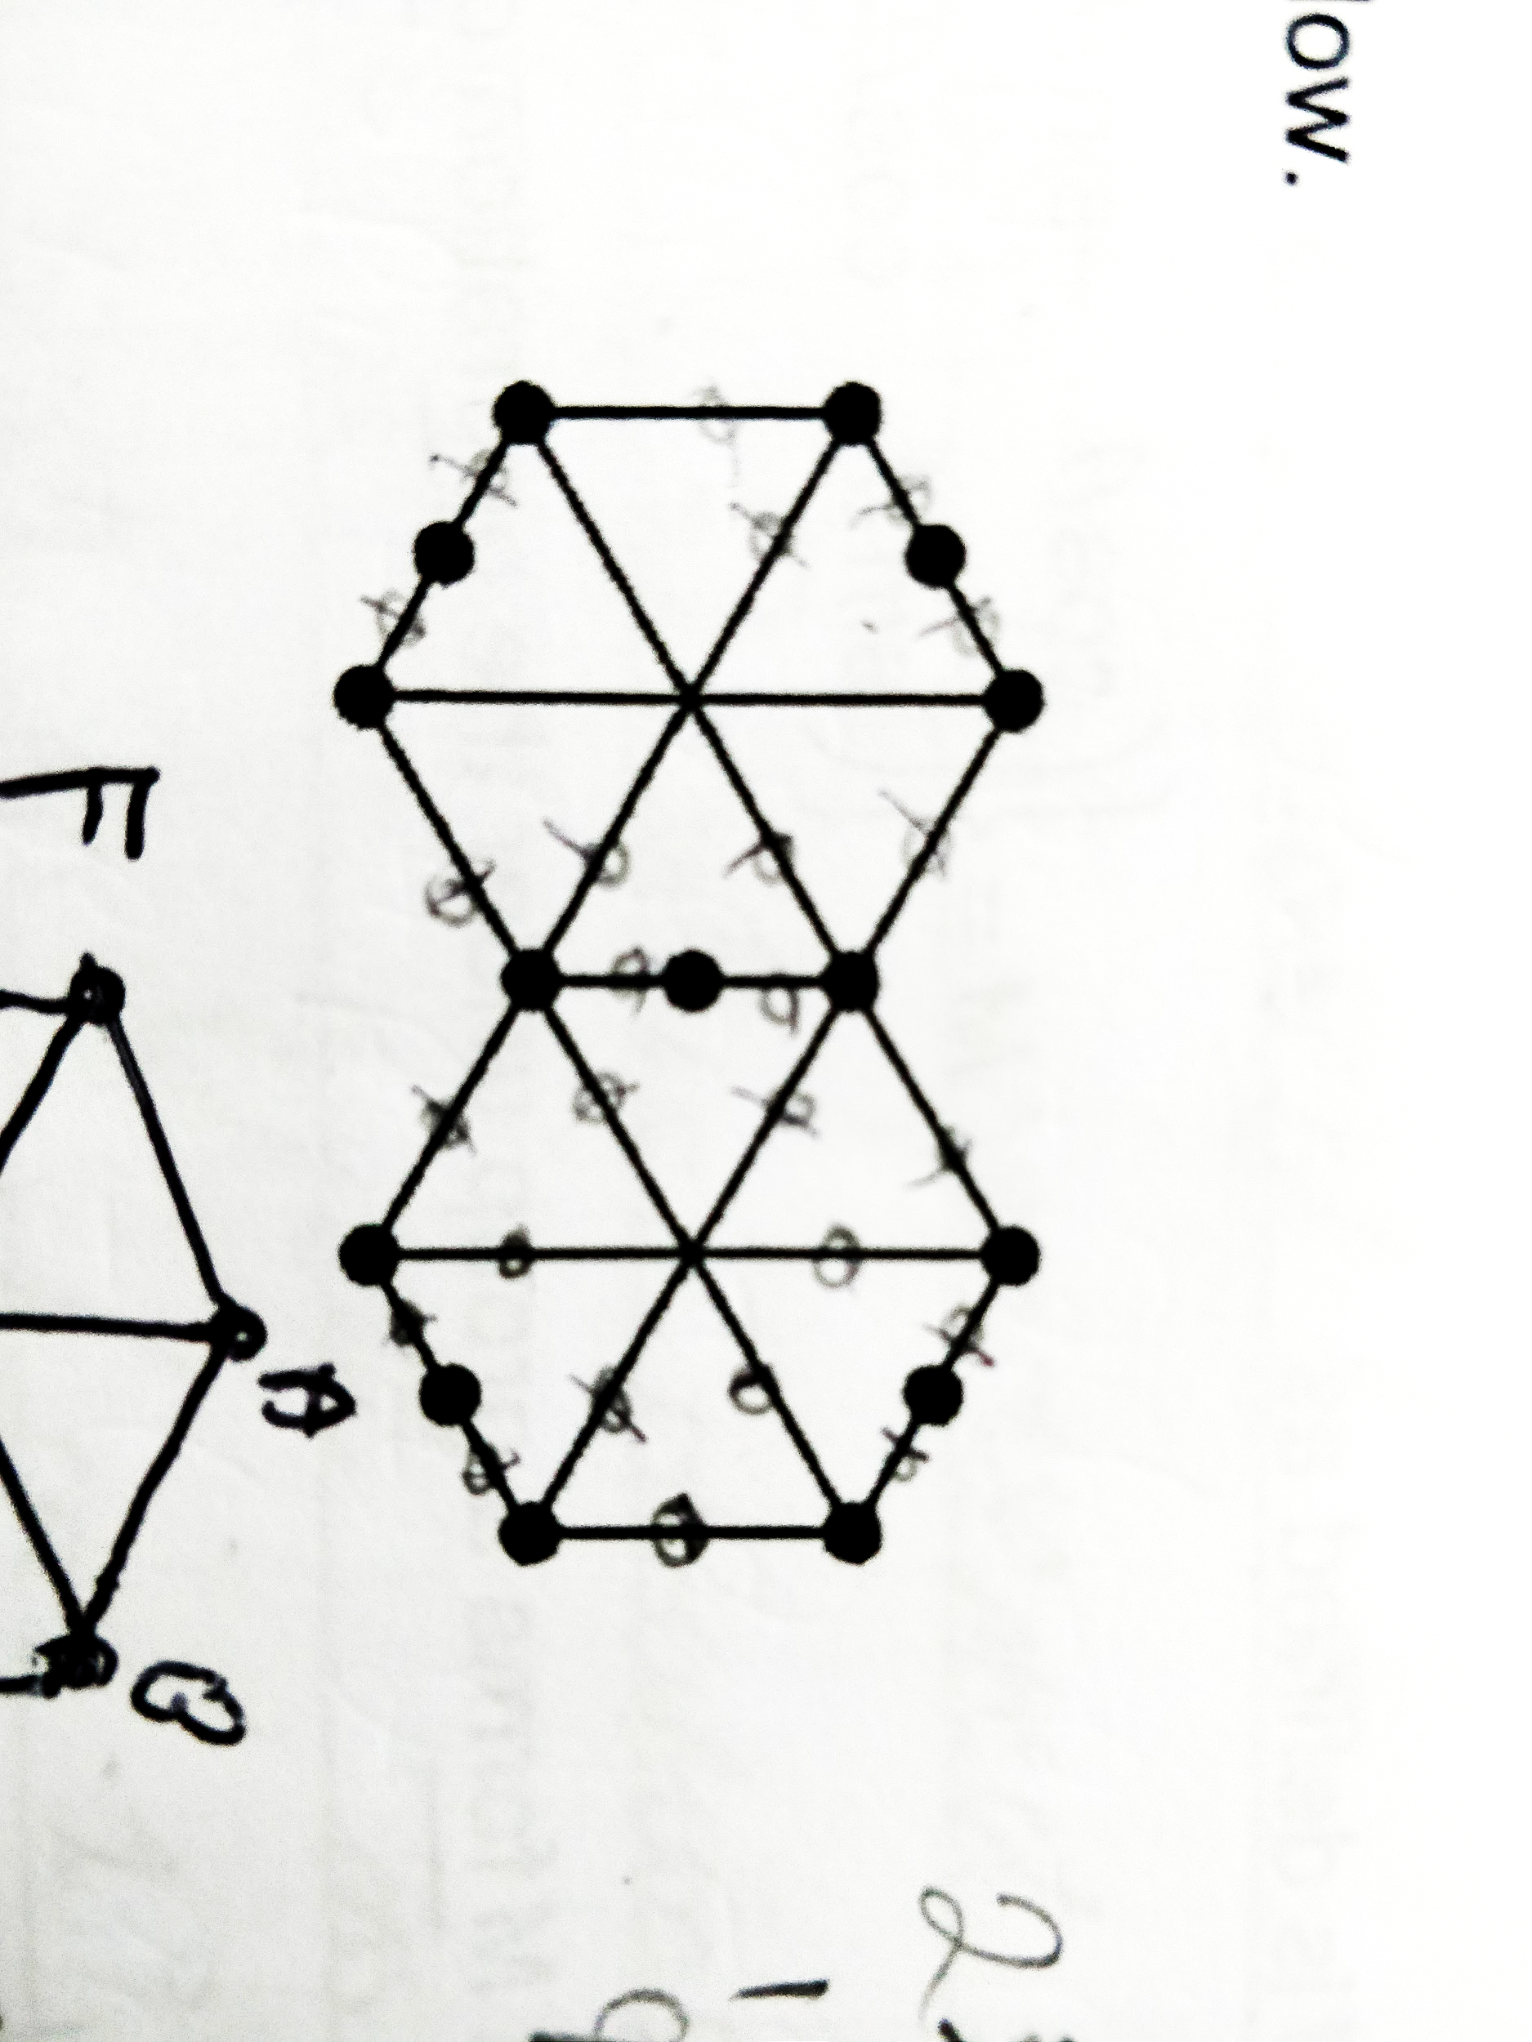

1. Let’s assume that the graph is planer so by Euler’s Formula: v + f - e = 2.
2. The graph has 15 vertices and 22 edges so must have 9 faces.
3. The shortest cycle in the graph has 5 edges so each face must have at least 5 edges. And each edge forms a boundary between 2 adjacent faces so 2E ≥ 5F.
4. However, 2E = 44 and 5F = 45 which is a contradiction thus N must be nonplanar.

*The below isn’t required but it is interesting.*

### Pigeonhole Principle

* If you must store n pigeons in k pigeonholes where n > k then at least 1 pigeonhole contains more than 1 pigeon.
* For handshakes, you can have: 0, 1, 2, 3, …, n - 1. Yet if someone shakes no hands, no one can shake n - 2 hands and if someone shakes all hands, no one can shake 0 hands. Thus we have n people with n - 1 choices thus 2 people will shake the same number of hands.

## DB - Networks

* When making an edge mandatory in a minimum spanning tree, add the edge and remove the largest arc that forms a cycle.
* Always go back to any route inspection questions at the end to make sure any indirect distance was, in fact, the shortest.
* Remember to expand any shortened path someone takes, they’re taking any indirect roots because the graph isn’t complete.

## DC - Network flows

* State ‘by the maximum-flow minimum-cut theorem’ when using it.

## DD - Linear programming

* Under Simplex, state that you stopped because “the objective row is entirely non-negative.”
* Remember to…
  + Declare the lower limits (e.g., x, y, z ≥ 0) if undefined.
  + Label the feasible region.
  + Use simultaneous equations to work out the exact amount.
  + Write “the number of … produced.”
* If it asks to ‘work out the profit’ then take into account cost.
* Move the ruler upwards rather than diagonally to maximise the profit (i.e., the y-intercept) until it hits the last vertex it can.
* A linear programming problem requiring integer solutions may require comparing the local integer coordinates to an optimal vertex.

### Objective Line

P = 3x + y ⇒ y = -3x + P

* And thus draw a gradient of -3 using the change in height and width idea.

## DE - Critical path analysis

* Ensure you perform the backwards pass properly - minus the duration from the late time ∵ if you think about it, it’s the latest an activity can start without delaying the project.
* When drawing cascade diagrams, ensure there’s no gaps along the y-axis to ensure all the workers have been used.

## DF - Game theory for zero-sum games

* Remember that you will have to keep switching perspectives.
* For the graph for an optimal mixed strategy, plot sensible scales (ie, 0 to 1 in 0.1 intervals since it is probability).
* The point of intersection is the maximum point where an outcome is **GUARANTEED**.
* When concluding an optimal mixed strategy, mention which strategies and with what probabilites.
* Show it requires a mixed strategy by showing no stable solution.

## DG - Binary operations and group theory

* Remember the mock question when you had to show a group was closed. For inverse, you could literally just find the inverse matrix and use odd/even functions. For identity, it was just a zero degree rotation. And for closed, you could just multiply 2 rotations and show they can be represented by a third. Don’t go for a very wordy approach.
* You cannot have two identity elements (e.g., one for a * b and another for b * a).
  + This is because… Suppose e and f are both identity elements then e * f = e where e is the identity element and e * f = f where f is the identity element. Thus e = f.
* Remember the mudolo symbol can be written as 7 +8 5 = 4 and 7 x4 5 = 3.
* Use Cayley Tables a lot more often, they can be very useful. Especially for finding inverses:

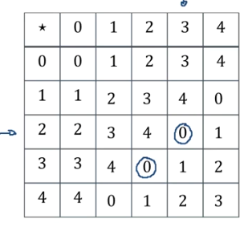

# Statistics

* You can use conditional probability here too, remember.

## SA - DRVs and expectation

* Use the fact that for the mean and variance of uniform distribution (1, 2, 3, ...) can related by a linear relationship.
* Write the formula for expected value to ensure you work it out correctly.

## SB & SC - Poisson distribution & type I/II errors

* If it asks you to state a distribution, it’s useful to state its meaning alongside it.
* You cannot conclude a test with certainty.
* Keep in mind that the hypotheses should be made about parameters (for Chi-Squared tests, it can be a statement).
* State the phrase “insufficient evidence to conclude that … at the … % level of significance” in any explanations.
* For a Type I error, you won’t get exactly 5% as Poisson is discrete, look for p-value of the critical value (may be 4.6%).
* Careful with parameters lambda and mu, use lambda for tests with Poission.

## SD - CRVs

* Remember that if you’re given a P(0 ≤ T ≤ t) = 22k - k(15 - 6)2 then this is from F(t) so you will need to differentiate to find f(t) to get the expected value.
* For working out cumulative distribution functions by integration, use + a, + b, + c after each integrated part and equate this from the start to find all of them. Be careful of gaps.

## SE - Chi tests for association

* Use fractions more often in this so you won’t have to type in as many numbers. Don’t round since rounding each value can drastically affect your answer.
* Make a plausible observation for any association (if there aren’t any, state the observed and expected frequencies are sufficiently close).
* The assumption made about the sample data for a chi-squared test to be valid is that a random sample is used.

## SF - Exponential distribution

* Try and spot λe-λx.

## SG & SH - t-distribution & confidence intervals

* Recognise when a t-test is being used and use inverse t, if necessary.
* A larger sample means a sample variance closer to the population variance.
* When it says to “fully justify your answer” then say a t-test / t-distribution was used as the n < 30 **and** population variance is unknown.